IWI PROJECT
RANDOM QUOTE GENERATOR

Objective : Generate motivational quotes from array/list

The Random Quote Generator is a simple web-based mini project developed using HTML, CSS, and JavaScript. The main purpose of this project is to display motivational quotes to the user when a button is clicked.
In this project, a list of quotes is stored inside a JavaScript array. Each time the user clicks the Generate Quote button, the program displays a new quote from the list in sequence. After the last quote is shown, the program starts again from the first quote. This approach avoids complex logic and makes the project easy to understand.

HTML is used to create the basic structure of the web page, such as headings, buttons, and text areas. CSS is used to design the layout and improve the appearance of the page. JavaScript is used to control the functionality of the button and to change the displayed quote dynamically without refreshing the page.
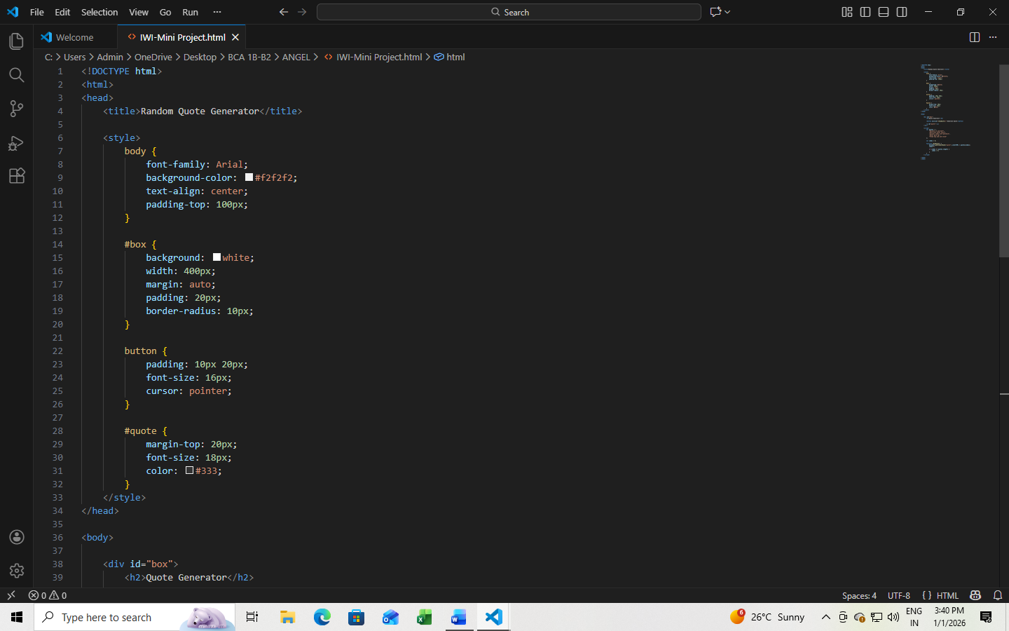
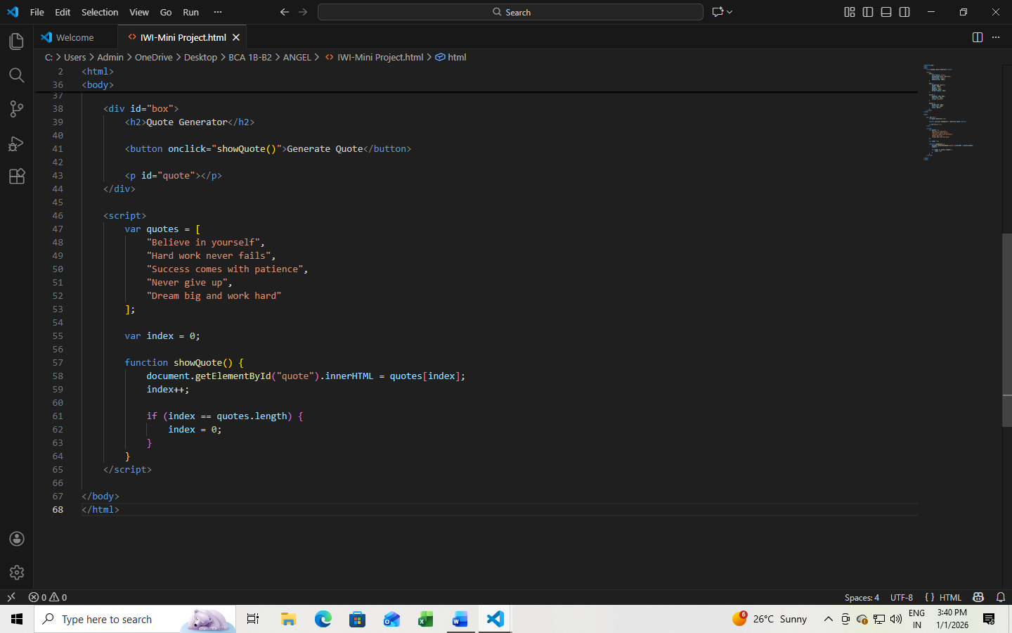
OUTPUT:

